**Using the airquality inbuilt dataset in R, plot a bar chart and**

**customize the colors and themes of the plot.**

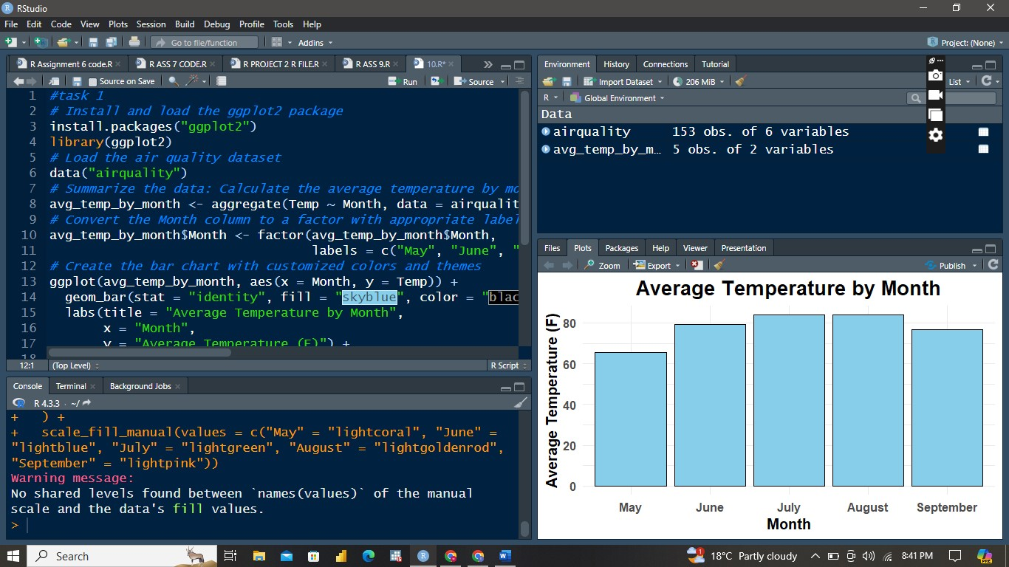

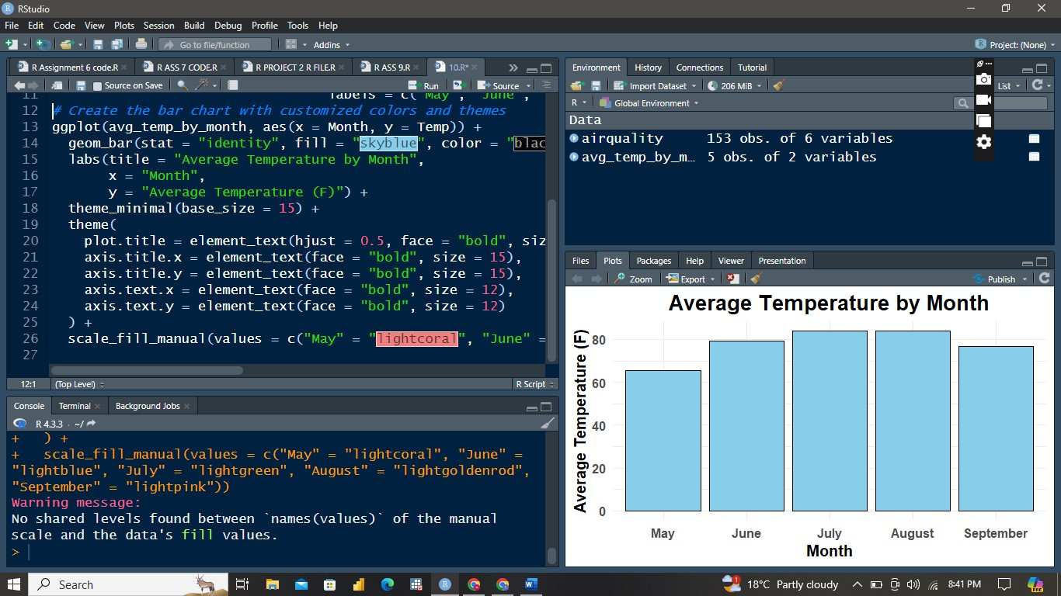

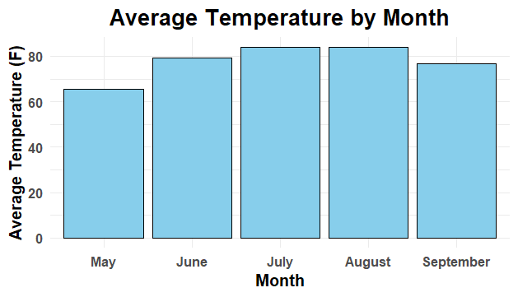

The bar chart shows the average temperature by month in New York from May to September 1973. Each bar represents the mean temperature for a specific month, revealing a trend of increasing temperatures as summer progresses.

* **May** has the lowest average temperature, indicating the transition from spring to summer.
* **June**, **July**, and **August** show progressively higher average temperatures, peaking in **July** and **August**, reflecting the hottest months of summer.
* **September** shows a decline, signaling the start of cooler fall weather.

This trend illustrates the expected seasonal temperature changes, with a peak during mid-summer and a gradual decline as autumn approaches.

**With the same dataset, plot a histogram, customize it, and**

**interpret the results.**

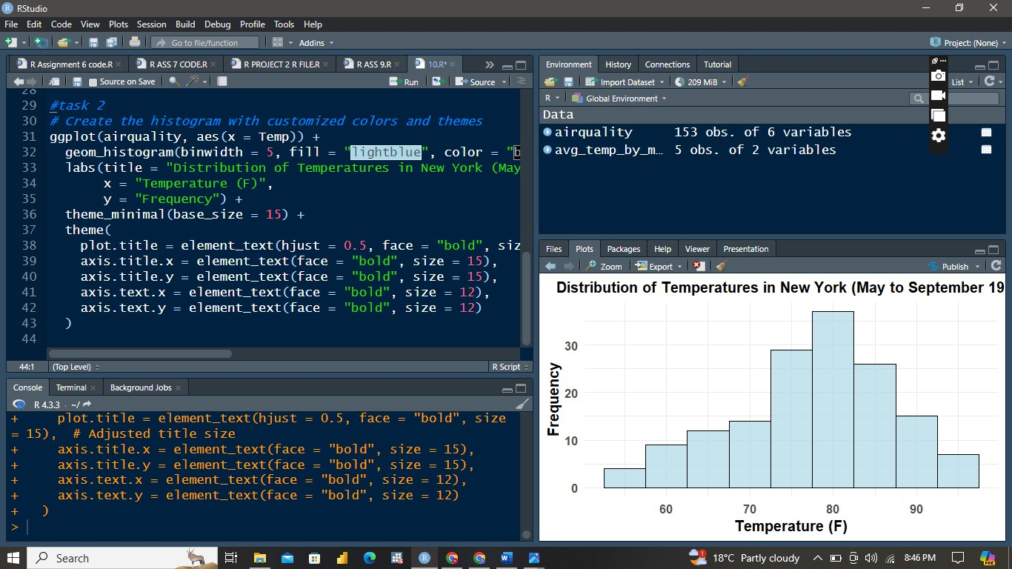

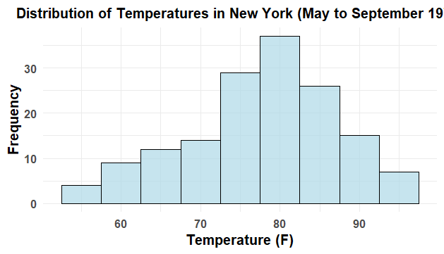

The histogram displays the distribution of temperatures in New York from May to September 1973. Most temperatures range from 70°F to 85°F, indicating these were the most common during this period. There are fewer occurrences of temperatures below 70°F and above 85°F, suggesting that extreme temperatures were less frequent. The distribution is slightly right-skewed, showing a tendency towards higher temperatures. This visual summary highlights the central tendency and variability of the temperatures, indicating that the summer months were generally warm, with the majority of days falling within the mid-range temperature bracket**.**